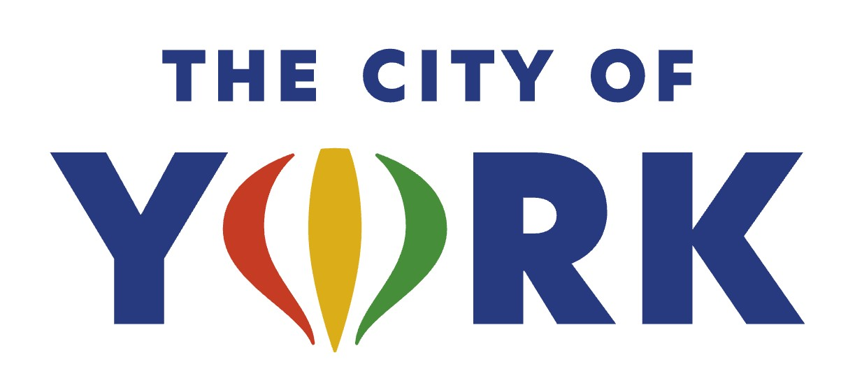
Recreation Coordinator

The City of York is hiring a full-time Recreation Coordinator for the Parks and Recreation Department. Under general supervision by the Director of Parks and Recreation the employee must coordinate, implement, supervise, teach and evaluate youth programs, adult leagues, special events, aquatic facilities, and aquatic programs. Develop, plan, organize and schedule year-round youth programs, adult leagues and events; oversee management of the outdoor and indoor pool; recruit, hire, train, supervise and evaluate a large staff of seasonal employees that include pool managers, lifeguards, admissions, sports officials, adult league supervisors, youth program supervisors and instructors; perform hands-on teaching functions; attend and monitor activities as required; develop lesson plans; research and develop new programs; coordinate athletic programs; assist in managing the Community Center, Family Aquatic Center and City Auditorium; assist in budget preparation and review program expenditures and revenue; promote programs and facilities through various methods; conduct public relation programs to encourage community involvement; serve as a liaison with participant groups and organizations; work evenings/nights and weekends when required; perform other duties as assigned.
Education: Bachelor’s degree in Recreation, Sports Management, Physical Education, Leisure Services or closely related field.
Experience: Three years of experience, with emphasis on youth programming, event coordinating and aquatic management. Must currently have First Aid, CPR/AED, Pool Operator, Lifeguard and Lifeguard Instructor certifications or be able to obtain within the first three months of employment.
This position has a 30-minute response time by way of the most direct route from the employee’s permanent residence to the employee’s assigned work site and within posted speed limits.
This position is an exempt position with a salary range of $52,550 - $70,422 annually based upon experience and qualifications. The City of York also provides and an excellent benefit package. Applicant must be 18 years of age, authorized to work in the United States and possess and maintain a valid driver’s license.
Apply online at www.cityofyork.ne.gov or email your application and resume to dpfeifer@cityofyork.ne.gov or mail to Denise Pfeifer, HR Director, 100 E. 4th Street, York NE 68467.
Applications will be accepted until the position is filled; first review will be January 6, 2026.
City of York is an Equal Opportunity Employer

